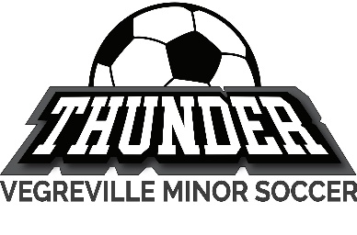
Athlete Protection Policy

“Organization” refers to: _Vegreville Minor Soccer Association__

Definitions

1. The following terms have these meanings in these Guidelines:

a) Athlete – Includes any individual who is registered to compete for the Organization.

b) Individuals – Refers to all categories of individual members and/or registrants defined in the Bylaws of
the Organization who are subject the policies of the Organization, as well as all people employed by,
contracted by, or engaged in activities with, the Organization including, but not limited to, employees,
contractors, Athletes, coaches, instructors, officials, volunteers, managers, administrators, committee
members, parents or guardians, spectators, and Directors.

c) Person in Authority – Any Individual who holds a position of authority within the Organization including,
but not limited to, coaches, instructors, officials, managers, support personnel, chaperones, committee
members, and Directors and Officers.

d) Vulnerable Individuals – Includes minors and vulnerable adults (people who, because of age, disability,
or other circumstance, are in a position of dependence on others or are otherwise at a greater risk than
the general population of being harmed by people in positions of trust or authority)

Purpose

2. This Athlete Protection Policy describe how Persons in Authority can maintain a safe sport environment for Athletes.

Interactions between Persons in Authority and Athletes – the ‘Rule of Two’

3. For interactions between Persons in Authority and Athletes, the Organization strongly recommends the ‘Rule of Two’ for all Persons in Authority who interact with Athletes. The ‘Rule of Two’ is a directive that says that an Athlete must never be alone one-on-one with an unrelated Person in Authority.

4. The Organization recognizes that fully implementing the ‘Rule of Two’ may not always be possible in some instances. Consequently, at a minimum, interactions between Persons in Authority and Athletes must respect the following:

  - a) The training environment should be open and transparent so that all interactions between Persons in
Authority and Athletes are observable.
  - b) Private or one-on-one situations must be avoided unless they are open and observable by another adult
or Athlete, who is preferably not a Vulnerable Individual.

  - c) Persons in Authority shall not invite or have a Vulnerable Individual (or Vulnerable Individuals) in their
home without the written permission and knowledge of the Vulnerable Individual's parent or guardian.

  - d) Persons in Authority must avoid situations where they are alone with a Vulnerable Individual without
another screened adult or Athlete, who is preferably not a Vulnerable Individual, present unless prior
written permission is obtained from the Vulnerable Individual's parent or guardian.
  - e) See Appendix A for full Canada Soccer Rule of Two Guideline.

Practices and Competitions

5. For practices and competitions, the Organization recommends:
a) A Person in Authority should never be alone with a Vulnerable Individual prior to or following a
competition or practice unless the Person in Authority is the Vulnerable Individual’s parent or guardian.
b) If the Vulnerable Individual is the first Athlete to arrive, the Vulnerable Individual’s parent or guardian
should remain until another Person in Authority or Athlete, who is preferably not a Vulnerable Individual,
arrives.
- c) If a Vulnerable Individual would potentially be alone with a Person in Authority following a competition
or practice, the Person in Authority should ask another Person in Authority (or a parent or guardian of
another Athlete) to stay until all the Athletes have been picked up. If an adult is unavailable, another
Athlete, who is preferably not a Vulnerable Individual, should be present to avoid the Person in Authority
being alone with a Vulnerable Individual.
- d) Persons in Authority giving instructions, demonstrating skills, or facilitating drills or lessons to an
individual Athlete should always do so within earshot and eyesight of another Person in Authority.

Communications

6. For communication between Persons in Authority and Athletes, the Organization recommends:
a) Group messages, group emails, or team pages are to be used as the regular method of communication
between Persons in Authority and Athletes.
b) Persons in Authority may only send texts, direct messages on social media, or emails to individual Athletes
when necessary and only for communicating information related to team issues and activities (e.g., non-
personal information). Any such texts, messages, or emails shall be professional in tone and must follow
the Rule of Two.
c) Electronic communication between Persons in Authority and Athletes that is personal in nature should be
avoided. If such communication occurs, it must be recorded and available for review by another Person
in Authority and/or by the Athlete’s parent or guardian (when the Athlete is a Vulnerable Individual).
d) Parents and guardians may request that their child not be contacted by a Person in Authority using any
form of electronic communication and/or to request that certain information about their child may not
be distributed in any form of electronic communications.
e) All communication between a Person in Authority and Athletes must be between the hours of 8:00 a.m.
and 10:00 p.m. unless extenuating circumstances justify otherwise.
f) Communication concerning drugs or alcohol use (unless regarding its prohibition) is not permitted.
g) No sexually explicit language or imagery or sexually oriented conversation may be communicated in any
medium.
h) Persons in Authority are not permitted to ask Athletes to keep a secret for them.

Travel

7. For travel involving Persons in Authority and Athletes, the Organization recommends:
a) Teams or groups of Athletes shall follow the Rule of Two.
b) For mixed gender teams or groups of Athletes, there should be one Person in Authority from each gender.
c) Screened parents or other volunteers will be available in situations when two Persons in Authority cannot
be present.
d) No Person in Authority may drive a vehicle alone with an Athlete unless the Person in Authority is the
Athlete’s parent or guardian.
e) A Person in Authority may not share a room or be alone in a hotel room with an Athlete unless the Person
in Authority is the Athlete’s parent or guardian.
f) Room or bed checks during overnight stays must be done by two Persons in Authority.
g) For overnight travel when Athletes must share a hotel room, roommates will be age-appropriate (e.g.,
within two years of age of one another) and of the same gender identity.

Locker Rooms / Changing Areas

8. For locker rooms, changing areas and other closed meeting spaces, the Organization recommends:
a) Interactions between Persons in Authority and Athletes should not occur in any area where there is a
reasonable expectation of privacy such as a locker room, washroom or changing area. A second adult
should be present for any necessary interaction between an adult and an Athlete in any such area.

b) If Persons in Authority are not present in the locker room or changing area, or if they are not permitted
to be present, they should still be available outside the locker room or changing area and be able to enter
the room or area if required, for reasons including but not limited to team communications and/or
emergencies.

Photography / Video

9. For all photography and video of an Athlete, the Organization recommends:
a) Photographs and video should only be taken in public view. Content must observe generally accepted
standards of decency and be both appropriate for and in the best interest of the Athlete.
b) The use of recording devices of any kind in rooms where there is a reasonable expectation of privacy is
strictly prohibited.
c) Examples of photos that shall be edited or deleted include:
i. Images with nudity or where undergarments are showing.
ii. Suggestive or provocative poses
iii. Images that are potentially embarrassing to the athlete.
d) If any photographs or videos will be used on any form of public media, an Image Consent Form (Appendix
B) must be completed before any images are taken and recorded where digital waivers are not
completed.
e) An Athlete, even a Minor Athlete, may revoke any consent they granted (or that was granted by their
parent/guardian) when an Image Consent Form was completed by submitting an Image Consent
Revocation Form (Appendix C).

Physical Contact

10. It is recognized that some physical contact between Persons in Authority and Athletes may be necessary for various reasons including, but not limited to, teaching a skill, or tending to an injury. Any physical contact shall respect the following:
a) Unless it is otherwise impossible because of serious injury or other justifiable circumstance, a Person in
Authority must always clarify with an Athlete where and why any physical contact will occur prior to the
contact occurring. The Person in Authority must make clear that he or she is requesting to touch the
Athlete and not requiring physical contact.

b) Infrequent, non-intentional physical contact during a training session is permitted.
c) Hugs lasting longer than five seconds, cuddling, physical horseplay, and physical contact initiated by the
Person in Authority is not permitted. It is recognized that some Athletes may initiate hugging or other
physical contact with a Person in Authority for various reasons (e.g., such as celebrating or crying after a
poor performance), but this physical contact should always be limited to circumstances where the Person
in Authority believes it is in the best interest of the Athlete and when it occurs in an open and observable
environment.

Appendix A
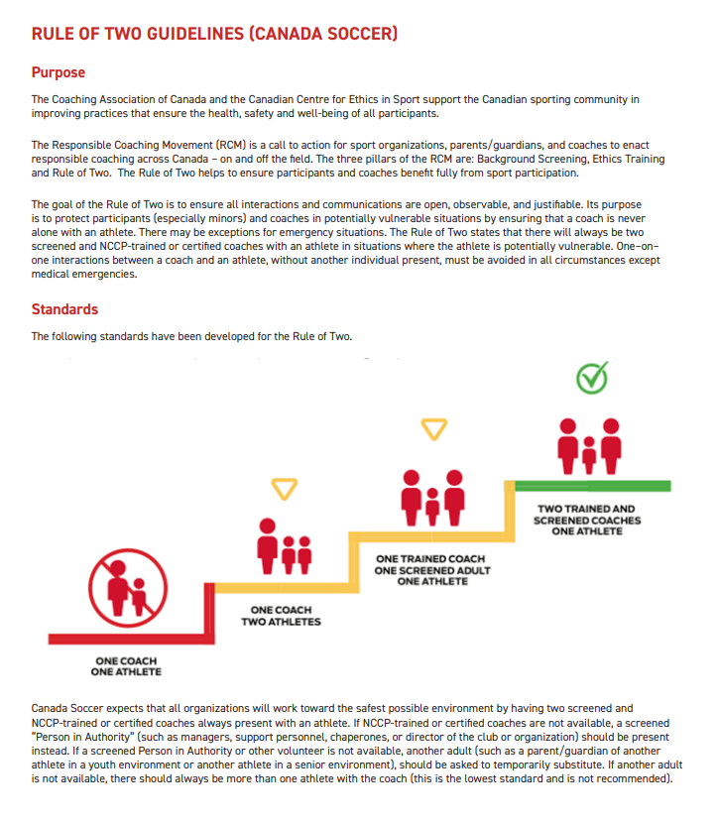
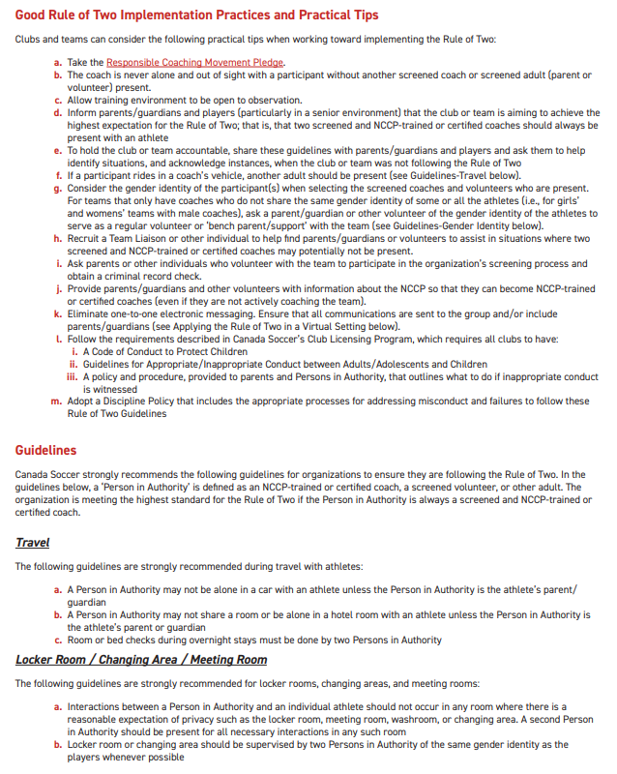
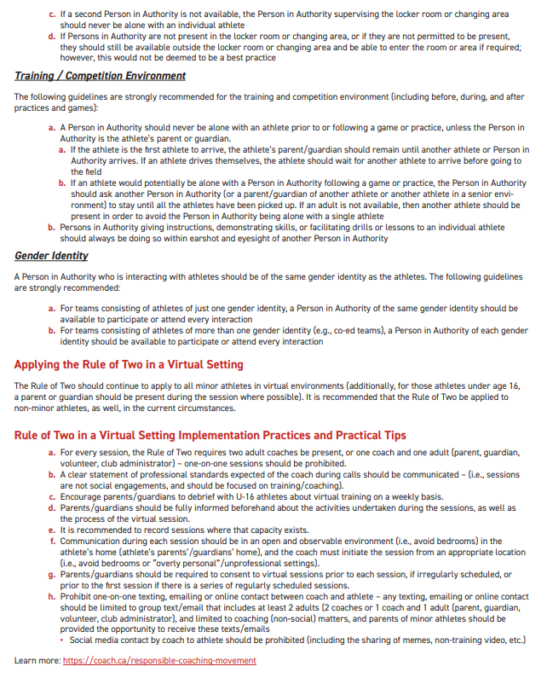
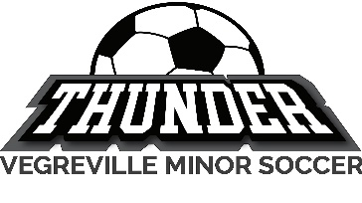
Appendix B – Photo and Video Consent Form

Name of Participant (print): ___________________________________________________________________

Name of Parent/Guardian (print): ______________________________________________________________
(When the Participant is younger than the age of majority)

Date: _______________________________________

1. I, being the Participant or the parent or legal guardian of the minor Participant, hereby grant to the Organization the permission to photograph and/or record the Participant’s image and/or voice in pictures or videos (collectively the “Images”), and to use the Images to promote the sport and/or the Organization through traditional media such as newsletters, websites, television, film, radio, print and/or display form, and through social media such as Instagram, Facebook, YouTube, and Twitter. I understand that I waive any claim to remuneration for use of audio/visual materials used for these purposes. This consent will remain in effect in perpetuity.

2. I, being the Participant or the parent or legal guardian of the minor Participant, hereby fully release, discharge, and agree to save harmless the Organization, from any and all claims, demands, actions, damages, losses or costs that might arise out of the collection, use or disclosure of the Images or taking, publication, distortion of the Images, negatives, and masters or any other likeness or representation of the Participant that may occur or be produced in the taking of said Images or in any subsequent processing thereof, including without limitation any claims for libel, passing off, misappropriation of personality, or invasion of privacy.

3. I, being the Participant or the parent or legal guardian of the minor Participant, UNDERSTAND AND AGREE, that I have read and understood the terms and conditions of this document. On behalf of myself, my heirs, and assigns, I agree that I am signing this document voluntarily and to abide by such terms and conditions.

Signature of Participant: _____________________________________________

OR, if the Participant is younger than the age of majority.

Signature of Parent/Guardian: _________________________________________
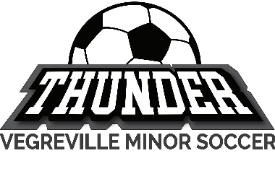
Appendix C – Image Consent Revocation Form

Name of Participant (print): ___________________________________________________________________

Name of Parent/Guardian (print): ______________________________________________________________
(When the Participant is younger than the age of majority)

Date: ________________________________________

1. I, being the Participant or the parent or legal guardian of the minor Participant, hereby revoke the permission that I had previously granted to the Organization to record the Participant’s image and/or voice on still or motion picture film and/or audio tape (collectively the “Images”), and revoke the permission that was granted to use the Images to promote the sport and/or the Organization through traditional media such as newsletters, websites, television, film, radio, print, and/or display form, and through social media such as Instagram, Facebook, YouTube, and Twitter. This revocation will remain in effect in perpetuity.

2. I, being the Participant or the parent or legal guardian of the minor Participant, UNDERSTAND AND AGREE, that I have read and understood the terms and conditions of this document. On behalf of me, my heirs, and assigns, I agree that I am signing this document voluntarily and to abide by such terms and conditions.

Signature of Participant: __________________________________________

OR, if the Participant is younger than the age of majority.

Signature of Parent/Guardian: _____________________________________

